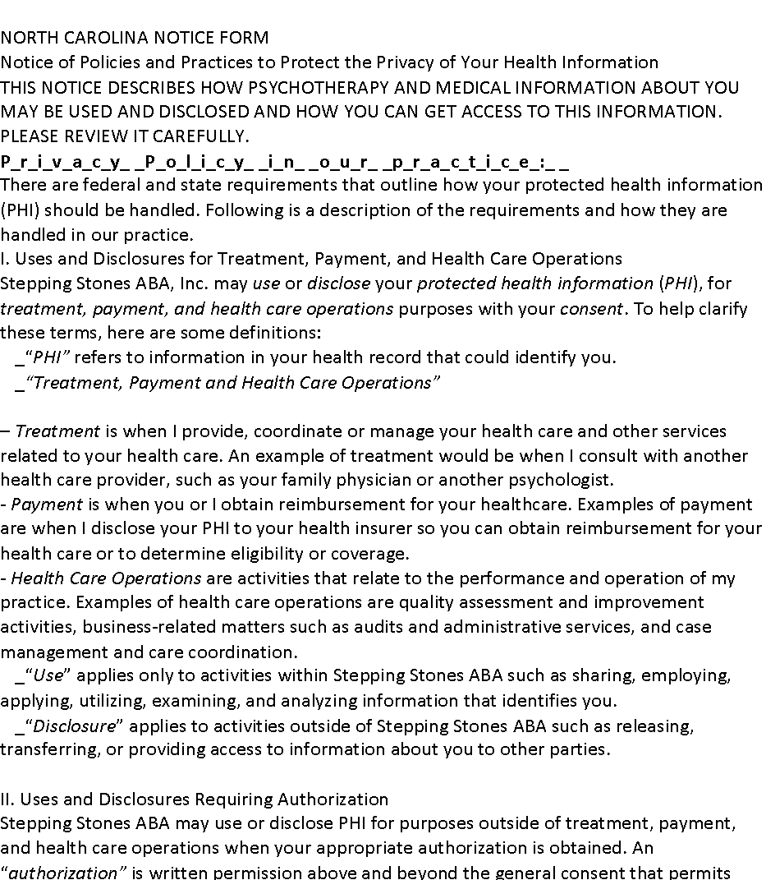
NORTH CAROLINA NOTICE FORM
Notice of Policies and Practices to Protect the Privacy of Your Health Information
THIS NOTICE DESCRIBES HOW PSYCHOTHERAPY AND MEDICAL INFORMATION ABOUT YOU MAY BE USED AND DISCLOSED AND HOW YOU CAN GET ACCESS TO THIS INFORMATION. PLEASE REVIEW IT CAREFULLY.
P_r_i_v_a_c_y_ _P_o_l_i_c_y_ _i_n_ _o_u_r_ _p_r_a_c_t_i_c_e_:_ _
There are federal and state requirements that outline how your protected health information (PHI) should be handled. Following is a description of the requirements and how they are handled in our practice.
I. Uses and Disclosures for Treatment, Payment, and Health Care Operations
Stepping Stones ABA, Inc. may use or disclose your protected health information (PHI), for treatment, payment, and health care operations purposes with your consent. To help clarify these terms, here are some definitions:
• _“PHI” refers to information in your health record that could identify you.
• _“Treatment, Payment and Health Care Operations”

– Treatment is when I provide, coordinate or manage your health care and other services related to your health care. An example of treatment would be when I consult with another health care provider, such as your family physician or another psychologist.
- Payment is when you or I obtain reimbursement for your healthcare. Examples of payment are when I disclose your PHI to your health insurer so you can obtain reimbursement for your health care or to determine eligibility or coverage.
- Health Care Operations are activities that relate to the performance and operation of my practice. Examples of health care operations are quality assessment and improvement activities, business-related matters such as audits and administrative services, and case management and care coordination.
• _“Use” applies only to activities within Stepping Stones ABA such as sharing, employing, applying, utilizing, examining, and analyzing information that identifies you.
• _“Disclosure” applies to activities outside of Stepping Stones ABA such as releasing, transferring, or providing access to information about you to other parties.

II. Uses and Disclosures Requiring Authorization
Stepping Stones ABA may use or disclose PHI for purposes outside of treatment, payment, and health care operations when your appropriate authorization is obtained. An “authorization” is written permission above and beyond the general consent that permits only specific disclosures. In those instances when we are asked for information for purposes outside of treatment, payment and health care operations, we will obtain an authorization from you before releasing this information. We will also need to obtain an authorization before releasing your therapy notes. “Therapy notes” are notes we may have made about our work during individual or group sessions, which we have kept separate from the rest of your medical record. These notes are given a greater degree of protection than PHI.
You may revoke all such authorizations (of PHI or psychotherapy notes) at any time, provided each revocation is in writing. You may not revoke an authorization to the extent that (1) We have relied on that authorization; or (2) if the authorization was obtained as a condition of obtaining insurance coverage, and the law provides the insurer the right to contest the claim under the policy.
III. Uses and Disclosures with Neither Consent nor Authorization
Stepping Stones ABA may use or disclose PHI without your consent or authorization in the following circumstances:

▪ _C_h_i_l_d_ _A_b_u_s_e_:_ _If you give us information which leads us to suspect child abuse, neglect, or death due to maltreatment, we must report such information to the county Department of Social Services. If asked by the Director of Social Services to turn over information from your records relevant to a child protective services investigation, we must do so.

▪ _A_d_u_l_t_ _a_n_d_ _D_o_m_e_s_t_i_c_ _A_b_u_s_e_:_ _If information you give us gives me reasonable cause to believe that a disabled adult is in need of protective services, we must report this to the Director of Social Services.

▪ _H_e_a_l_t_h_ _O_v_e_r_s_i_g_h_t_:_ _The North Carolina Psychology Board has the power, when necessary, to subpoena relevant records should we be the focus of an inquiry.

• _J_u_d_i_c_i_a_l_ _o_r_ _A_d_m_i_n_i_s_t_r_a_t_i_v_e_ _P_r_o_c_e_e_d_i_n_g_s_:_ _If you are involved in a court proceeding, and a request is made for information about the professional services that we have provided you and/or the records thereof, such information is privileged under state law, and we must not release this information without your written authorization, or a court order. This privilege does not apply when you are being evaluated for a third party or where the evaluation is court ordered. You will be informed in advance if this is the case.

• _S_e_r_i_o_u_s_ _T_h_r_e_a_t_ _t_o_ _H_e_a_l_t_h_ _o_r_ _S_a_f_e_t_y_:_ _Stepping Stones ABA may disclose your confidential information to protect you or others from a serious threat of harm by you.

•
IV. Patient's Rights
• _Right to Request Restrictions –You have the right to request restrictions on certain uses and disclosures of protected health information about you. However, we are not required to agree to a restriction you request.
• _Right to Receive Confidential Communications by Alternative Means and at Alternative Locations – You have the right to request and receive confidential communications of PHI by alternative means and at alternative locations. (For example, you may not want a family member to know that you are seeing us. Upon your request, we will send your bills to another address.)
• _Right to Inspect and Copy – You have the right to inspect or obtain a copy (or both) of PHI in my mental health and billing records (but not including therapy notes), used to make decisions about you for as long as the PHI is maintained in the record. You must submit your request in writing. We may deny your access to PHI under certain circumstances, but in some cases, you may have this decision reviewed. On your request, we will discuss with you the details of the request and denial process.
• _Right to Amend – You have the right to request an amendment of PHI for as long as the PHI is maintained in the record. Stepping Stones ABA may deny your request. On your request, we will discuss with you the details of the amendment process.
• _Right to an Accounting – You generally have the right to receive an accounting of disclosures of PHI for which you have neither provided consent nor authorization (as described in Section III of this Notice). On your request, we will discuss with you the details of the accounting process.
• _Right to a Paper Copy – You have the right to obtain a paper copy of the notice from me upon request, even if you have agreed to receive the notice electronically or other means by which information is sent to you.

V. Complaints
If you are concerned that we have violated your privacy rights, or you disagree with a decision we made about access to your records, you may file a complaint by writing to us at our office address. You may also send a written complaint to the Secretary of the U.S. Department of Health and Human Services.
VI. Effective Date, Restrictions and Changes to Privacy Policy
This notice will go into effect on April 1, 2007.
Stepping Stones ABA reserves the right to change the privacy policies and practices described in this notice. If we revise our policies and procedures, we will post a copy of our current Notice in our office or on our website. You may request, and we will provide, a copy of our most current Notice at any time.

INFORMED CONSENT

I ________________________________________, have received, read, and understand the Stepping Stones ABA, Inc. Notice of HIPPA Policy.

Parent/Guardian Date

